Monosaccharides

There are 3 types of monosaccharide: glucose, galactose and sucrose.
They all have the formula C₆H₁₂O₆.
They are all hexose sugars.

Glucose:
- Blood sugar.
- Forms starch in plants, and glycogen in animals.
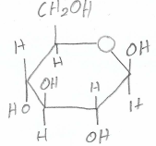
Galactose:
- Non-sweet sugar.
- Forms lactose (found in milk).
- The only difference from glucose is that the hydroxyl group (carbon 4) is reversed, as glucose has the HO at the top, galactose has the HO at the bottom.
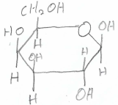
Fructose:
- Fruit sugar.
- Sweeter than glucose.
- Forms sucrose (table sugar).
- It is a 5 sided ring which contains 2 CH₂OH groups – carbons 2 & 5.
